Fairness and wellbeing commission evidence from Citizens Advice Doncaster Borough November 2022
Any evidence or data, specific to Doncaster, that you hold about social inequalities and fairness that may be of use to the commission?
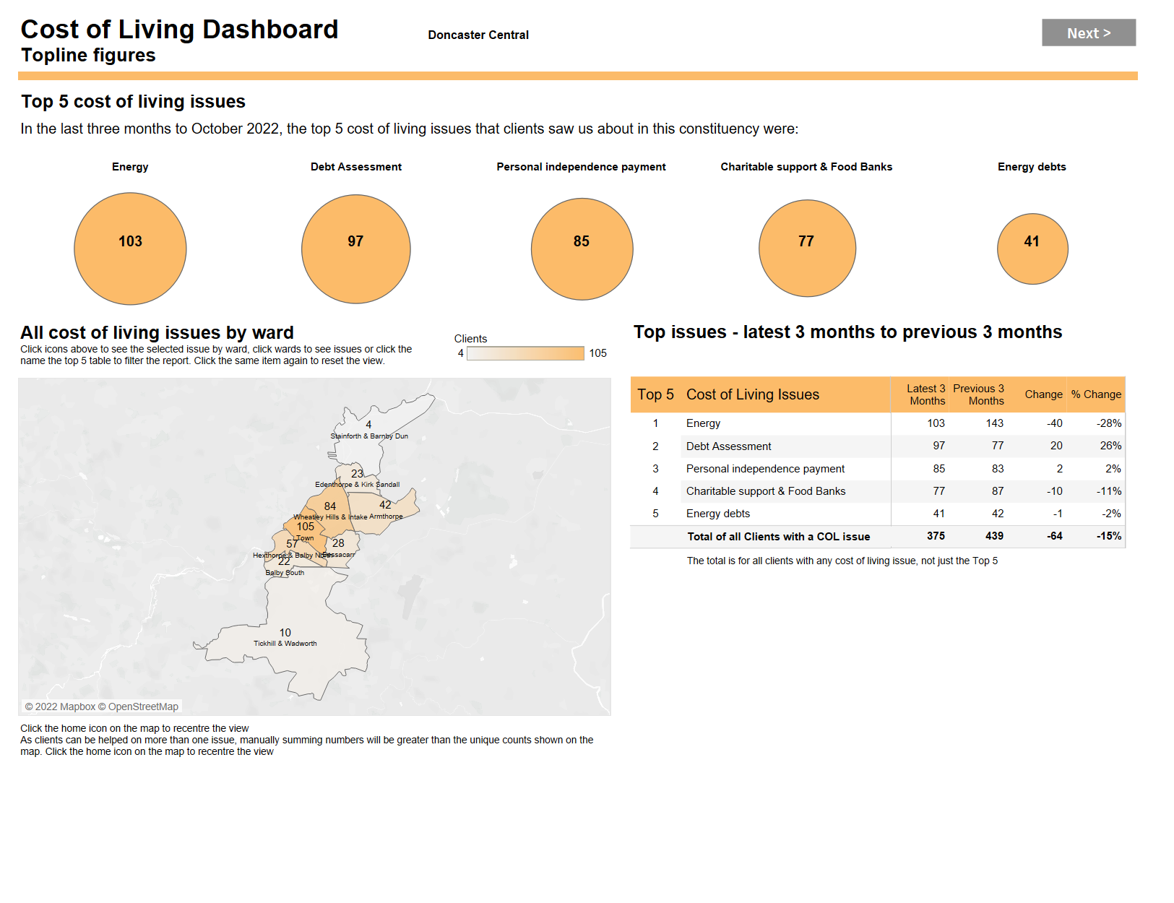
Source: Citizens Advice Cost of Living Data Tableau October 2022 showing the top five issues clients are visited central Doncaster office about
Based on your evidence what is your organisation’s analysis of the cause/s of some of the social inequalities in Doncaster
Alleviation of poverty and access to services would help to do this, this means addressing issues re lack of service provision and barriers to access to services such as digital exclusion and locality isolation. Although we are aware the locality hubs are addressing some of these issues as is our localities project
Are there any examples of good practice in relation to reducing social inequalities and increasing fairness (from within the city, elsewhere or overseas) that the commission should be aware of?
Citizens advice work to alleviate social inequalities with its advice provision both nationally and locally providing a wide variety of services including benefits advice and debt, help to claim assisting clients with universal credit and the new energy advice project More details are on the new website https://www.cadoncasterborough.org
What do you or your organisation believe would be the best way to tackle social inequalities and increase fairness in the city?
Fairer access to services across the board which would help to assist with alleviation of poverty
What do you believe should be the top 3 priorities for our city?
Addressing the ongoing cost of living issues for the residents of Doncaster. Fairer or more open access to services for all and the alleviation of poverty

